Designing for follow‑through: Rethinking online scheduling at UCS
In the spring 2024 semester, University Counseling Services (UCS) launched online scheduling to increase flexibility and reduce barriers for students seeking counseling services. While this service was popular with students, appointment scheduling and attendance data from the 2024-25 academic year revealed an unexpected challenge with this new scheduling option. Although online scheduling made it easier for students to book initial consultations, it also corresponded with lower attendance, especially during high-demand months (September through October and February through March).
To better understand this pattern, UCS analyzed attendance trends using exported scheduling data. A clear relationship emerged—when appointments were scheduled farther in advance, the likelihood of a no-show increased. Longer lead times appeared to weaken follow-through, which in turn reduced UCS’s ability to meet demand and provide timely support to students who requested services. Recognizing this, UCS reduced the scheduling window from four weeks to two weeks in March 2025. The goal was straightforward: shorten the time between a student’s decision to seek support and their appointment, reinforcing commitment and lowering the chance of missed sessions.
Early results from fall 2025 indicate that this adjustment made a meaningful difference. With a two‑week scheduling window, UCS saw fewer drop-offs and improved appointment utilization during peak periods. By using appointment data to understand trends, UCS is able to continue to offer flexible options for scheduling appointments, while also addressing no-show rates for appointments.

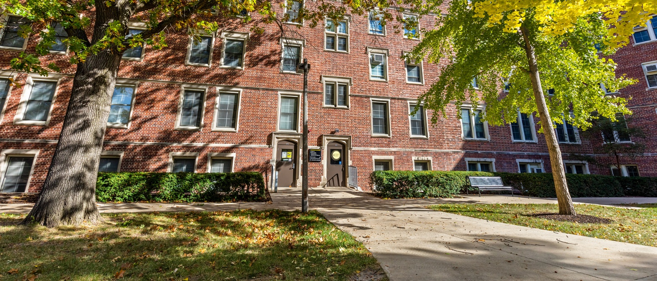

March 2026

