The hawkeyesports arcade: a hub of connection and recreation on campus
Since its grand opening, the HawkeyEsports Arcade at the University of Iowa has become a vibrant hub for students seeking connection and recreation. Nestled within the Iowa Memorial Union, this state-of-the-art facility has welcomed thousands of visitors, quickly establishing itself as a cornerstone of campus life.
The HawkeyEsports Arcade offers a unique space where students can bond over their shared passion for gaming. Whether it's the thrill of competitive play or the joy of casual gaming, the arcade provides an inclusive environment where everyone can find their niche. With a variety of gaming consoles, high-performance PCs, and a wide selection of games, there's something for every type of gamer.
During the 2025 academic year, the HawkeyEsports Arcade has recorded an impressive 9,084 swipes, reflecting its popularity and the vital role it plays in student life. Since 2022, there have been over 10,000 swipes into the HawkeyEsports Arcade every year.
For many, it's more than just a place to play games; it's a sanctuary where they can unwind, de-stress, and connect with friends. It offers a much-needed break from the rigors of academic life, providing a space where students can relax and recharge.

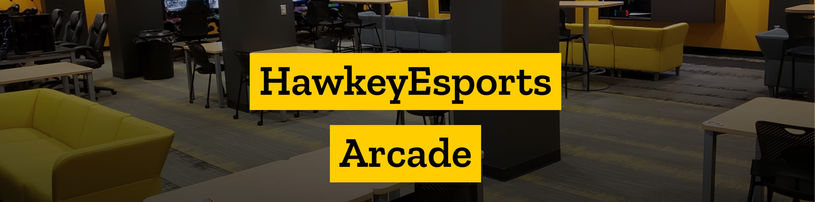

March 2025

