Setting the Standard for Excellence in Fraternity and Sorority Life
The vision for Fraternity and Sorority Life (FSL) at the University of Iowa is to create an environment for students, chapters, councils, and the overall community to develop the knowledge, skills, and behaviors to achieve their individual and collective goals through intentional coaching, education, and programming. In alignment with our vision, this spring, FSL replaced the Annual Report with the new Hawkeye Excellence and Goal Achievement Program, which includes recognition requirements that align with university standards and ten focus areas with expectations that define what it means to be a successful chapter at Iowa. The purpose of this shift was to help support the planning and infrastructure development for chapters, collect data to meaningfully tell the FSL story and recognize chapters’ accomplishments annually, and for chapters to set annual goals based on the data collected from their efforts the previous year.
Since implementing this new program, the staff has been able to incorporate planning documents and data submitted into 1:1 coaching conversations with chapter leadership, along with sharing trends of prevention education completion with council leadership to identify and address barriers for completion. This has included meeting with all new member educators and intake officers to discuss their curriculum and facilitation so that chapters can provide the best experience for new members as they acclimate to their chapter and our community. Additionally, we have seen an increase in education completion rates that focus on topics like sexual violence prevention.
Since setting the expectation for completion, FSL has seen a 12.5% education completion increase across the community from 2024 to 2025.
As FSL continues to utilize the new Hawkeye Excellence and Goal Achievement Program to set the standard for our community, FSL encourages you to visit the website or reach out to learn more about the details and how students and chapters can engage in campus programs, resources, and support to meet the expectations outlined in the program.
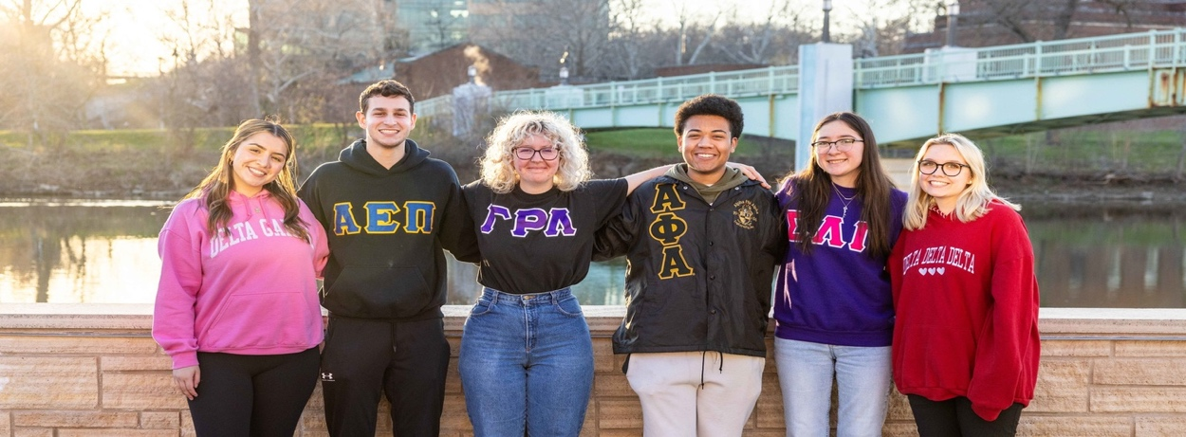
June 2025

