Listening in Real Time: Student Insights from Engagement Fest
At the recent Engagement Fest held at the Iowa Memorial Union, staff used intercept surveys to gather insights from 50 students. This method, where students were randomly approached and asked to complete a brief survey, proved effective in understanding their motivations and preferences.
The survey revealed that:
47% of students attended the event to get more involved on campus
76% of students said social media is the best way to hear about future events
32% of students heard about the event through word of mouth & 25% saw it on Instagram
These findings highlight the importance of using diverse methods to gauge the impact of our programs. By leveraging intercept surveys, we can gather valuable, real-time feedback directly from students. This approach ensures our events are well-promoted and meet the needs of our campus community.

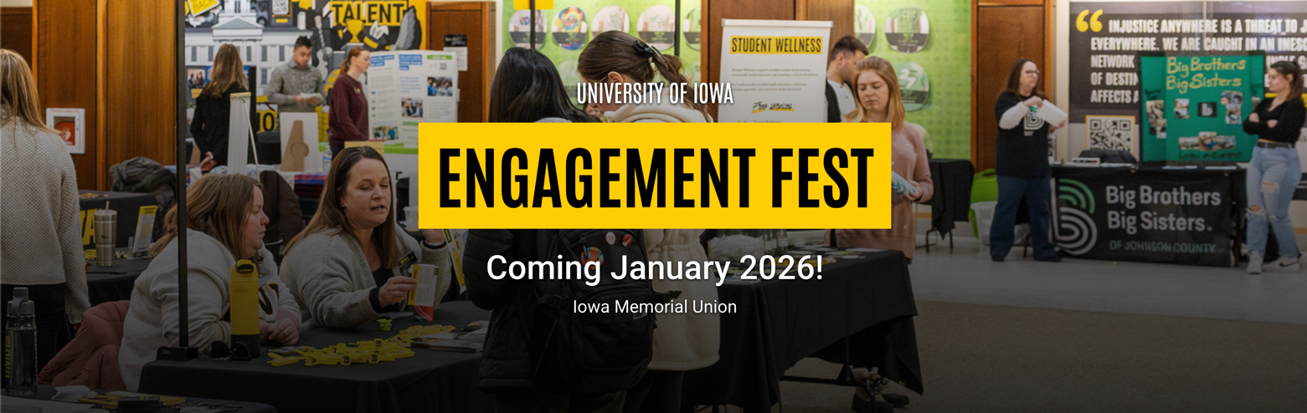

January 2025

