A path to success: The journey with student legal services
Imagine Charlie, a first-generation college student, who struggled when their landlord refused to return their security deposit. The stress affected their studies, but Student Legal Services (SLS) stepped in to help. They recovered Charlie’s deposit and empowered them with knowledge for the future. Charlie felt more confident and connected to the university, knowing they had support. Charlie’s hypothetical story is just one example of the impact that SLS has on students and student success.
In the fiscal year of 2024, SLS assisted 778 students with 624 cases, handling a variety of legal issues from criminal cases to landlord-tenant disputes.
There was a 40% increase in students receiving full-scope legal representation and a 95% increase in attendance at outreach events. SLS's impact goes beyond legal victories.
According to the FY24 report, 94% of students felt less stressed after their SLS appointment, and 85% felt less distracted from their studies.
This support helps students stay focused on their academic goals. Navigating legal issues could be daunting, but Student Legal Services provides support to help students thrive through life's ups and downs.
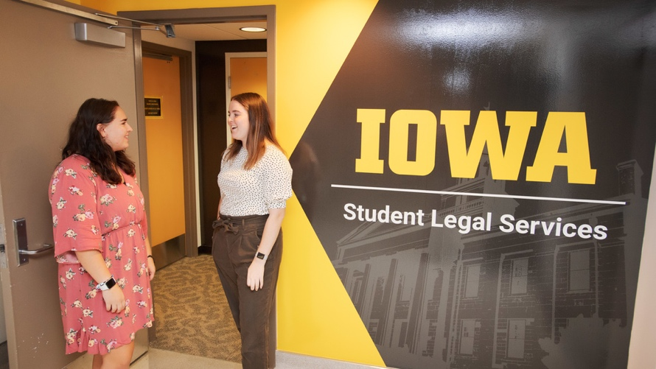

February 2025

