The Heart of the Division: A Story of Student Employment at Iowa
In the bustling rhythm of campus life, the Division of Student Life quietly hums with the energy of over two thousand student employees. From the kitchens of University Dining to the front desks of Recreational Services, these students are not just filling shifts—they are shaping their futures.
Each spring, a survey goes out, asking student employees to reflect on their experiences. In 2025, nearly 650 students responded, offering a vivid portrait of what it means to work while learning. The responses painted a clear picture: student employment is transformational.
Students reported that their jobs helped them grow in ways that extended far beyond the workplace. Time management, communication, and critical thinking were among the most commonly cited skills. Those who participated in Iowa GROW® conversations reported even greater benefits. They were more likely to feel prepared for full-time employment, to see links between their jobs and their coursework, and to feel supported by their supervisors.
Supervisors also play a pivotal role. The majority of students said their supervisors understood the demands of academic life and worked with them to create flexible schedules. Many felt genuinely valued, not just as workers, but as individuals. Recognition came in many forms—verbal praise, thank-you notes, even promotions—and it mattered. Students said these moments of acknowledgment made them feel seen.
But the impact of student employment wasn’t just professional. It was personal. Over half of the respondents said their jobs helped them build meaningful connections. Others spoke of the confidence they gained, the sense of purpose they found, and the friendships that blossomed in break rooms and behind service counters.
In the end, the story of student employment in the Division of Student Life is not about any one person. It’s about a community—one that learns, grows, and thrives together.
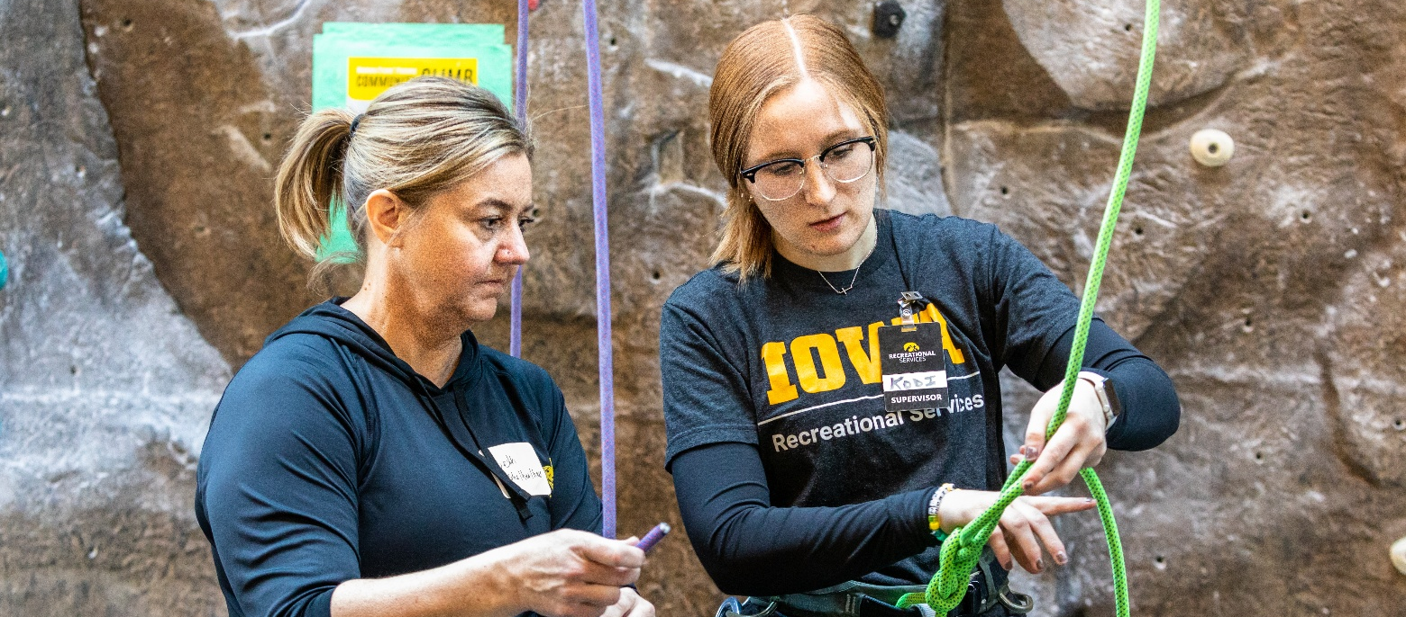
August 2025

