From Texts to Tastes: How Student Feedback Shapes Dining
At University Dining, the Text N Tell program has become an essential tool for gathering ongoing feedback from students. This program allows students to text their feedback directly to dining staff, who respond and implement changes based on the suggestions. Some of these responses are displayed on monitors around the dining facilities to show students that their feedback is heard and utilized.
A few changes made possible through the Text N Tell program:
Vegan soft serve added to ice cream station
Sweet and sour chicken added to menu
Asiago bagels, avocado, and tomatoes added to breakfast bar
Milk/juice shortages addressed promptly with restocking or supplier updates
Burger cooking methods changed for juicier patties
Puppy chow added to Sunday menu
Fried eggs added to breakfast a few times a week
New condiments, beverage syrups, and ice cream toppings added per student suggestions

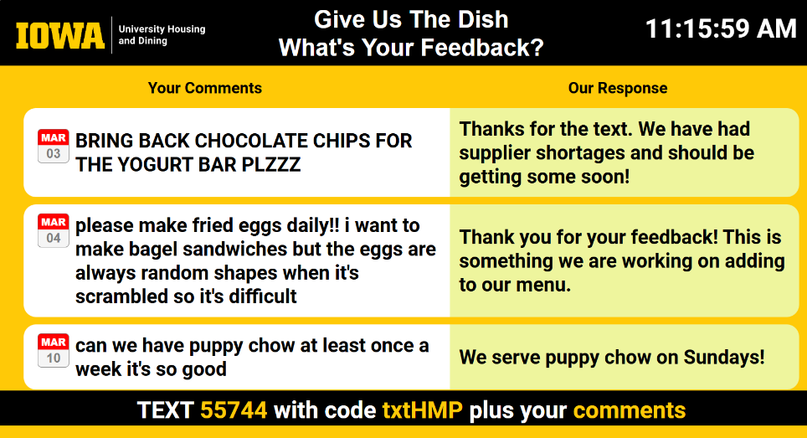

Through the Text N Tell program, University Dining has created a dynamic and responsive dining experience that caters to the needs and desires of students. The changes made are displayed on monitors around the dining facilities, closing the feedback loop and demonstrating that student voices are valued and acted upon.

April 2025

